Примерни задачи от състезанията за 5 клас

Първите въпроси от теста са свързани с четене с разбиране. Учениците четат кратък текст и отговарят на 5-6 въпроса, свързани с него. Останалите упражнения се отнасят до познаване на граматика и лексика.
1. Order the words in a sentence.
1. two / he / has / sister / brothers / and / a.

…………………………………………………………………………………………
2. go / Saturday / every / the girls / to the club.

…………………………………………………………………………………………
3. at / does / his / he / the kitchen table / homework.

…………………………………………………………………………………………
4. lunch / do / break / not / go / home / during / the / I.

…………………………………………………………………………………………
5. I / your / borrow / can / please / pencil?

…………………………………………………………………………………………
6. you / get / a / bus / can / there.

…………………………………………………………………………………………

2. Read and complete. 3. Write the plurals of the nouns.
1. ....... she a dancer? No, ................ 1. man - …………………….
2. ....... they from Japan? Yes, .......... 2. woman - …………………
3. ....... he a bus driver? No, ............. 3. child - ……………………
4. ....... it a pet? No, .................... 4. family - …………………….
5. ....... they dirty? Yes, .................. 5. person - …………………….
6. ....... Mary from Italy? No, ............ 6. boy - ……………………….

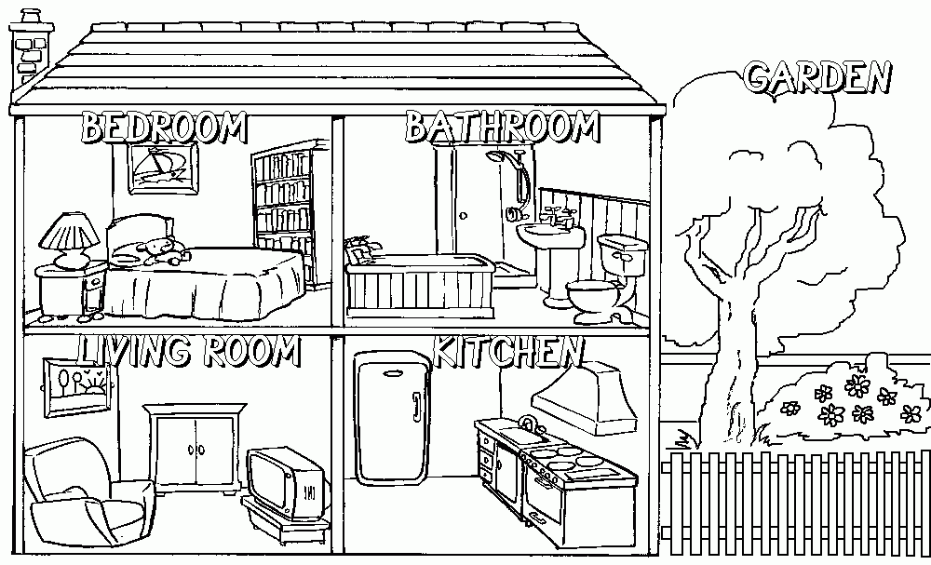
4 Answer the question.
1. Where is the TV?
…………………………………….

2. Where is the teddy?
…………………………………….

3. Where are the flowers?
…………………………………….
4. Where are the books?
…………………………………….

