Примерни задачи от състезанията за 3 клас

1. Попълни с There is / There are. 2. Напиши числото с думи.
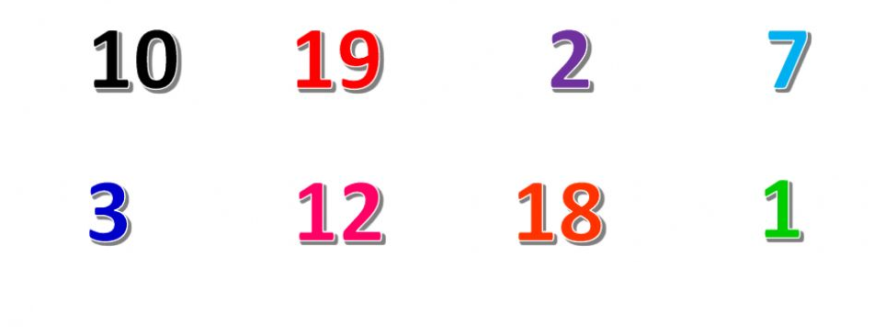
- _________________ a lamp.
- _________________ three windows.
- _________________ a bed.
- _________________ a pillow.
- _________________ four tables.
- _________________ a newspaper.

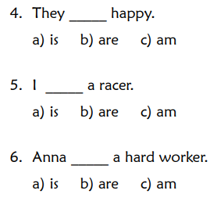
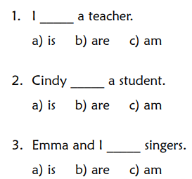
3. Огради правилната форма на “to be”.

4. Подреди думите в изречение.

1. your / mum’s / What / name / is? _______________________________________
2. reading / new / a / book / I’m. ____________________________________________
3. his / riding / My brother / is / bike. ________________________________________
4. aren’t / We / cheese / eating / sandwiches. __________________________________
5. like / They / singing / songs. _____________________________________________
6. We / walking / park / in the / are. ______________________________________

